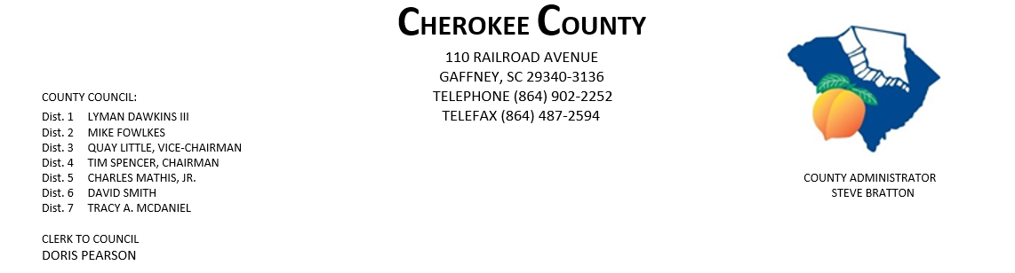

AGENDA FOR THE REGULAR MEETING OF COUNTY COUNCIL
MONDAY, SEPTEMBER 16, 2019, 5:00 P.M.
CHEROKEE COUNTY ADMINISTRATION BUILDING
COUNTY COUNCIL CHAMBERS, 1st FLOOR
110 RAILROAD AVENUE, GAFFNEY, SC 29340

01. CALL TO ORDER: Chairman Tim Spencer
02. INVOCATION:
03. WELCOME VISITORS:
04. ROLL CALL:
05. ADOPT AGENDA:
06. APPROVAL OF MINUTES: Public Hearing & Regular Meeting of 9/3/19.
07. APPROVAL OF CLAIMS: for Cherokee County in the amount of $329.548.79.

08. JUDICIAL SERVICES COMMITTEE CHAIR MIKE FOWLKES: Courthouse & Law Enforcement Center
Security Upgrades

09. ATTORNEYS JOE MATHIS & JIM THOMPSON:

10. EXECUTIVE SESSION PURSUANT TO SECTION 30-4-70: for the purpose of discussing a contractual
matter regarding the Gaffney Fire
Protection Area.

11. ADMINISTRATOR STEVE BRATTON: 1) Employee Grievance Committee Appointments

2) Cherokee County Quality of Life Video

PAGE 2 – AGENDA FOR REGULAR MEETING, 9/16/19

12. APPOINTMENTS: 1) Upstate EMS Council – 1 appointment – full council

2) Cherokee Co. Tax Assessor/Board of Appeals – Dist. 1 – Dawkins
5 - Mathis

3) Cherokee Co. Board of Adjustments & Appeals – Dist. 1 – Dawkins
3 - Little
5 – Mathis
At-Large - Council

4) Cherokee Co. Citizen Planning Commission – Dist. 1 – Dawkins
5 - Mathis 7 - McDaniel

5) Appalachian COG Board (Minority position) – Full council.

6) CKC VFD – Dist. 7 – McDaniel

7) Cherokee Co. Public Library Board – Dist. 4 – Spencer

8) Goucher-White Plains Fire District – Dist. 5 – Mathis

9) Cherokee County Development Board – Dist. 3 – Little

10) Cherokee Co. Employee Grievance Committee – full council

11) Cherokee Co. Recreation District Board – full council.

13. NEW/OLD/OTHER BUSINESS:

14. ADJOURNMENT

dfp
9/13/19

