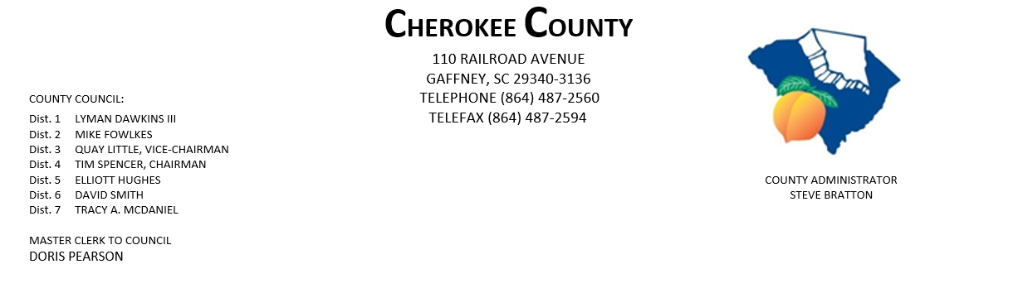
AGENDA FOR THE PUBLIC HEARINGS & REGULAR MEETING OF COUNTY COUNCIL
MONDAY, DECEMBER 7, 2020, 5:00 P.M.
CHEROKEE COUNTY ADMINISTRATION BUILDING
COUNTY COUNCIL CHAMBERS, 1st FLOOR
110 RAILROAD AVENUE, GAFFNEY, SC 29340

- CALL TO ORDER: Chairman Tim Spencer

- INVOCATION:

- ROLL CALL:

- ADOPT AGENDA:
5. APPROVAL OF MINUTES: Public Hearing & Regular Meeting of 11/16/2020
6. APPROVAL OF CLAIMS: for Cherokee County in the amount of $873,766.07.

7. PUBLIC HEARINGS:
- regarding Ordinance No. 2020-19 authorizing pursuant to Title 12, Chapter 44 of
the Code of Laws of SC 1976, as amended, the execution & delivery of an amended
& restated Fee-in-Lieu of Taxes Agreement by & between Cherokee Co., One World Technologies, Inc., and Hart Consumer Products, Inc. (formerly identified by the County as
Project Blue Cell, its affiliates and related entities to provide for a Fee in Lieu of Taxes Incentive and Certain Special Source Revenue Credits; and other matters related thereto.

- regarding Ordinance No. 2020-20 to amend the agreement for Development for Joint Co.
Industrial Park by & between Spartanburg Co. & Cherokee Co., SC, so as to include additional property in Spartanburg Co. as part of the Joint County Industrial Park, and other matters relating thereto. (Duncan Industrial Owner, LLC; Blue Ridge Log Cabins; New Spartanburg Owner, LP: Smith Animal Hospital, PA.; Micheline North America, Inc.; Spartanburg RE Investments, LLC; Tietex International, LTD.; Victor Park Holdings, LLC; Drayton Holdings, LLC; IGP NA Operations, LLC; Siemens Industry, Inc. & Siemens Corp., Inc.; and Milliken & Company.)
PAGE 2 – AGENDA FOR PH & REGULAR MEETING, 12/7/20

08. PRESENTATION:
- Community Vision and Strategic Plan Reveal – The Palladian Group
- County Website Reveal – The Palladian Group

09. RESOLUTION: No. 2020-05 authorizing a 10-Year Extension of the Term under the Fee Agreement
by & between the County and Old Castle Matt Stone Holdings, Inc., successor in
interest to Matt Stone of SC., Inc.; and other matters related thereto.
10. ORDINANCES:
- 2nd Reading of Ordinance No. 2020-21 authorizing the execution & delivery of an amended & restated Fee in Lieu of Tax & Special Source Revenue Credit Agreement by & between Cherokee Co. and Project Sunshine 2020 with respect to certain economic development property in the County, whereby such property will be subject to certain payments in Lieu of Taxes, including the provision of Certain Special Source Revenue Credits; and other matters related thereto.

- 2nd Reading of Ordinance No. 2020-22 authorizing the lease of County property to the
Cherokee County School District.

- 3rd Reading of Ordinance No. 2020-19 authorizing pursuant to Title 12, Chapter 44 of
the Code of Laws of SC,1976, as amended, the execution & delivery of an amended & restated Fee-in-Lieu of Taxes Agreement by & between Cherokee Co. and an entity identified by the County as Project Blue Cell, its affiliates and related entities, to provide for a Fee-in-Lieu of Taxes Incentive, and Certain Special Source Revenue Credits, and other matters related thereto.

- 3rd Reading of Ordinance No. 2020-20 to amend the Agreement for Development for Joint County Industrial Park by & between Spartanburg & Cherokee Counties, SC, so as to include additional property in Spartanburg Co as part of the Joint County Industrial Park, and other matters relating thereto. (Duncan Industrial Owner, LLC; Blue Ridge Log Cabins; New Spartanburg Owner, LP; Smith Animal Hospital, PA; Micheline North America., Inc.; Spartanburg RE Investment, LLC; Tietex International, LTD; Victor Park Holdings, LLC; Drayton Holdings, LLC; IGPNA Operations, LLC; Siemens Industry, Inc. & Siemens Corp, Inc.; and Milliken & Co.)

11. ATTORNEY JOE MATHIS:

12. ACTION ITEMS:
- Cherokee County Council Scheduled Meeting Dates for Year 2021

13. ADMINISTRATOR STEVE BRATTON:
- other information
PAGE 3 – AGENDA FOR PH & REGULAR MEETING, 12/7/2020

14. EXECUTIVE SESSION: pursuant to Section 30-4-70(a)(2) for the purpose of discussions concerning a
contractual matter.

15. ACTION TO BE TAKEN FROM EXECUTIVE SESSION:

16. APPOINTMENTS:

a. Appalachian Council of Governments – full council

b. Cherokee Co. Tax Assessor/Board of Appeals
i. Dist. 1 – Dawkins
ii. Dist. 2 - Fowlkes
iii. Dist. 3 - Little
iv. Dist. 4 - Spencer
v. Dist. 5 - Hughes
vi. Dist. 6 – Smith

c. Cherokee Co. Board of Adjustments & Appeals
i. Dist. 1 – Dawkins
ii. Dist. 2 – Fowlkes
iii. Dist. 3 – Little
iv. Dist. 5 - Hughes
v. Dist. 6 - Smith
vi. At-Large – Council

d. Cherokee Co. Citizen Planning Commission
    - Dist. 1 – Dawkins
    - Dist. 5 - Hughes

e. Cherokee Commission on Alcohol & Drug Abuse
i. Dist. 2 - Fowlkes
ii. Dist. 3 – Little
iii. Dist. 5 - Hughes
v. Dist. 6 – Smith

f. Cherokee Co. Development Board – Dist. 2 Fowlkes

g. CKC VFD - Dist. 7 – McDaniel

h. Cherokee Co. Recreation District Board – full council.

PAGE 4 – AGENDA FOR PH & REGULAR MEETING, 12/7/2020

16. APPOINTMENTS CONTINUED:

i. Cherokee Creek Fire District/BOC – one appointment - Dist. 2 – Fowlkes & Dist. 4 - Spencer

j. Corinth Fire District/Board of Commissioners – Dist. 3, 5 & 6 – Little, Hughes & Smith

k. Goucher-White Plains Fire Dist. – Dist. 5 - Hughes

l. Piedmont Community Actions Board of Directors – full council

m. Upstate Workforce Board – full council

17. NEW/OLD/OTHER BUSINESS:

18. ADJOURNMENT:

dfp
12/4/20

