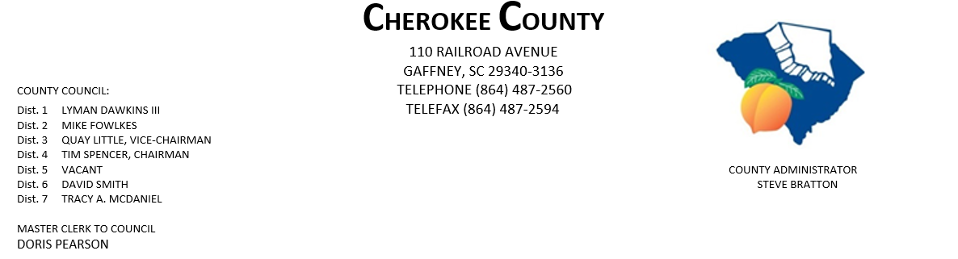
AGENDA FOR THE PUBLIC HEARING & REGULAR MEETING OF COUNTY COUNCIL
MONDAY, NOVEMBER 16, 2020, 5:00 P.M.
CHEROKEE COUNTY ADMINISTRATION BUILDING
COUNTY COUNCIL CHAMBERS, 1st FLOOR
110 RAILROAD AVENUE, GAFFNEY, SC 29340

*** SWEARING IN CEREMONY FOR NEWLY ELECTED CHEROKEE COUNTY
DISTRICT 5 COUNCILMEMBER ELLIOTT HUGHES ***

- CALL TO ORDER: Chairman Tim Spencer

- INVOCATION:

- ROLL CALL:

- ADOPT AGENDA:
5. APPROVAL OF MINUTES: Regular Meeting of 11/2/2020
6. APPROVAL OF CLAIMS: for Cherokee County in the amount of $307,456.17.

7. PUBLIC HEARING: regarding Ordinance No. 2020-18 amending the Cherokee County Code
Chapter 11 Fire Protection, Article 11, Section 11-93 Gaffney Fire District;
Ad valorem tax – annual levy.

8. EXECUTIVE SESSION: pursuant to Section 30-4-70(a)(2) for the purpose of:

- receiving legal advice concerning a contractual matter.
- discussion of matters relating to future proposed locations, expansions or provisions of services including locations & expansions of industries or other businesses in the area served by a public body specifically Project Sunshine.

9. ACTION TO BE TAKEN FROM EXECUTIVE SESSION:

PAGE 2 – AGENDA FOR PH & REGULAR MEETING, 11/16/20

10. ORDINANCES:

- 1st Reading of Ordinance No. 2020-21 authorizing the execution & delivery of an amended & restated Fee in Lieu of Tax & Special Source Revenue Credit Agreement by & between Cherokee Co. and Project Sunshine 2020 with respect to certain economic development property in the County, whereby such property will be subject to certain payments in Lieu of Taxes, including the provision of Certain Special Source Revenue Credits; and other matters related thereto.

- 1st Reading of Ordinance No. 2020-22 authorizing the lease of County property to the
Cherokee County School District.

- 2nd Reading of Ordinance No. 2020-19 authorizing pursuant to Title 12, Chapter 44 of
the Code of Laws of SC,1976, as amended, the execution & delivery of an amended & restated Fee-in-Lieu of Taxes Agreement by & between Cherokee Co. and an entity identified by the County as Project Blue Cell, its affiliates and related entities, to provide for a Fee-in-Lieu of Taxes Incentive, and Certain Special Source Revenue Credits, and other matters related thereto.

- 2nd Reading of Ordinance No. 2020-20 to amend the Agreement for Development for Joint County Industrial Park by & between Spartanburg & Cherokee Counties, SC, so as to include additional property in Spartanburg Co as part of the Joint County Industrial Park, and other matters relating thereto. (Duncan Industrial Owner, LLC; Blue Ridge Log Cabins; New Spartanburg Owner, LP; Smith Animal Hospital, PA; Micheline North America., Inc.; Spartanburg RE Investment, LLC; Tietex International, LTD; Victor Park Holdings, LLC; Drayton Holdings, LLC; IGPNA Operations, LLC.)

- 3rd Reading of Ordinance No. 2020-18 amending the Cherokee County Code Chapter 11 Fire Protection, Article 11, Section 11-93 Gaffney Fire District; Ad valorem tax – annual levy.

11. ATTORNEY JOE MATHIS:

12. ACTION ITEMS:
- Gaffney Fire Protection Area Contract

13. ADMINISTRATOR STEVE BRATTON:
- other information

PAGE 3 – AGENDA FOR PH & REGULAR MEETING, 11/16/2020

14. APPOINTMENTS:

a. Appalachian Council of Governments – full council

b. Cherokee Co. Tax Assessor/Board of Appeals
i. Dist. 1 – Dawkins
ii. Dist. 2 - Fowlkes
iii. Dist. 3 - Little
iv. Dist. 4 - Spencer
v. Dist. 5 - Hughes
vi. Dist. 6 – Smith

c. Cherokee Co. Board of Adjustments & Appeals
i. Dist. 1 – Dawkins
ii. Dist. 2 – Fowlkes
iii. Dist. 3 – Little
iv. Dist. 5
v. Dist. 6 - Smith
vi. At-Large – Council

d. Cherokee Co. Citizen Planning Commission
    - Dist. 1 – Dawkins
    - Dist. 5 -
    - Dist. 7 – McDaniel

e. Cherokee Commission on Alcohol & Drug Abuse
i. Dist. 2 - Fowlkes
ii. Dist. 3 – Little
iii. Dist. 5 - Hughes
v. Dist. 6 – Smith

f. Cherokee Co. Development Board – Dist. 2 Fowlkes

g. CKC VFD - Dist. 7 – McDaniel

h. Cherokee Co. Recreation District Board – full council.

i. Cherokee Creek Fire District/BOC – one appointment - Dist. 2 – Fowlkes & Dist. 4 - Spencer

j. Goucher-White Plains Fire Dist. – Dist. 5

k. Piedmont Community Actions Board of Directors – full council

l. Upstate Workforce Board – full council

PAGE 4 – AGENDA FOR PH & REGULAR MEETING, 11/16/2020

15. NEW/OLD/OTHER BUSINESS:

16. ADJOURNMENT:

dfp
11/13/20

