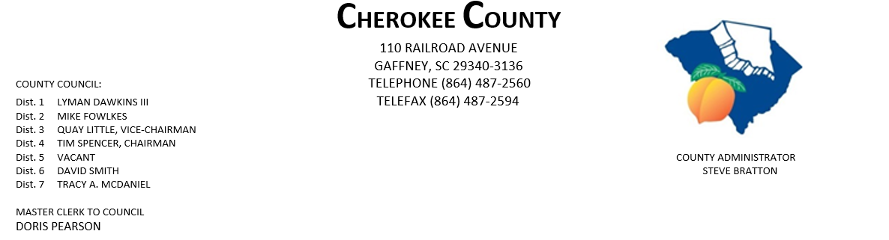
AGENDA FOR THE REGULAR MEETING OF COUNTY COUNCIL
MONDAY, NOVEMBER 2, 2020, 5:00 P.M.
CHEROKEE COUNTY ADMINISTRATION BUILDING
COUNTY COUNCIL CHAMBERS, 1st FLOOR
110 RAILROAD AVENUE, GAFFNEY, SC 29340

- CALL TO ORDER: Chairman Tim Spencer

- INVOCATION:

- ROLL CALL:

- ADOPT AGENDA:
5. APPROVAL OF MINUTES: Regular Meeting of 10/19/2020 & Special Call Meeting 10/27/2020
6. APPROVAL OF CLAIMS: for Cherokee County in the amount of $416,147.08.

7. ORDINANCES:
- 1st Reading of Ordinance No. 2020-19 authorizing pursuant to Title 12,
Chapter 44 of the Code of Laws of SC,1976, as amended, the execution &
delivery of an amended & restated Fee-in-Lieu of Taxes Agreement by &
between Cherokee Co. and an entity identified by the County as Project Blue
Cell, its affiliates and related entities, to provide for a Fee-in-Lieu of Taxes
Incentive, and Certain Special Source Revenue Credits, and other matters
related thereto.

- 1st Reading of Ordinance No. 2020-20 to amend the Agreement for Development
for Joint County Industrial Park by & between Spartanburg & Cherokee Counties, SC,
so as to include additional property in Spartanburg Co as part of the Joint County
Industrial Park, and other matters relating thereto. (Duncan Industrial Owner, LLC;
Blue Ridge Log Cabins; New Spartanburg Owner, LP; Smith Animal Hospital, PA;
Micheline North America., Inc.; Spartanburg RE Investment, LLC; Tietex International,
LTD; Victor Park Holdings, LLC; Drayton Holdings, LLC; IGPNA Operations, LLC.)
PAGE 2 – AGENDA FOR REGULAR MEETING, 11/2/2020

7. ORDINANCES CONTINUED:

- 2nd Reading of Ordinance No. 2020-18 amending the Cherokee County Code
Chapter 11 Fire Protection, Article 11, Section 11-93 Gaffney Fire District;
Ad valorem tax – annual levy.

8. ATTORNEYS JOE MATHIS & JIM THOMPSON:

9. ADMINISTRATOR STEVE BRATTON:
- County Logo
- Community visioning & strategic plan update
- SCAC Revenue, Finance & Economic Development Steering Committee information
- other information

10. APPOINTMENTS:
a. Appalachian Council of Governments – full council

b. Cherokee Co. Tax Assessor/Board of Appeals
i. Dist. 1 – Dawkins
ii. Dist. 2 - Fowlkes

c. Cherokee Co. Board of Adjustments & Appeals
i. Dist. 1 – Dawkins
ii. Dist. 2 – Fowlkes
iii. Dist. 3 – Little
iv. Dist. 5
v. Dist. 6 - Smith
vi. At-Large – Council

d. Cherokee Co. Citizen Planning Commission
    - Dist. 1 – Dawkins
    - Dist. 2 - Fowlkes
    - Dist. 5 -
    - Dist. 7 – McDaniel

e. CKC VFD - Dist. 7 – McDaniel

f. Cherokee Co. Recreation District Board – full council.

g. Cherokee Creek Fire District/BOC – one appointment - Dist. 2 – Fowlkes & Dist. 4 - Spencer

h. Goucher-White Plains Fire Dist. – Dist. 5
PAGE 3 – AGENDA FOR THE REGULAR MEETING, 11/2/2020

10. APPOINTMENTS CONTINUED:

i. Piedmont Community Actions Board of Directors – full council

j. Upstate Workforce Board – full council

11. EXECUTIVE SESSION: pursuant to Section 30-4-70(a)(2) for the purpose of
- receiving legal advice concerning a contractual matter.
- discussion of matters relating to future proposed locations, expansions or provisions of services including locations & expansions of industries or other businesses in the area served by a public body specifically Project Blue Cell.

12. ACTION TO BE TAKEN FROM EXECUTIVE SESSION:

13. NEW/OLD/OTHER BUSINESS:

14. ADJOURNMENT:

dfp
10/30/20

