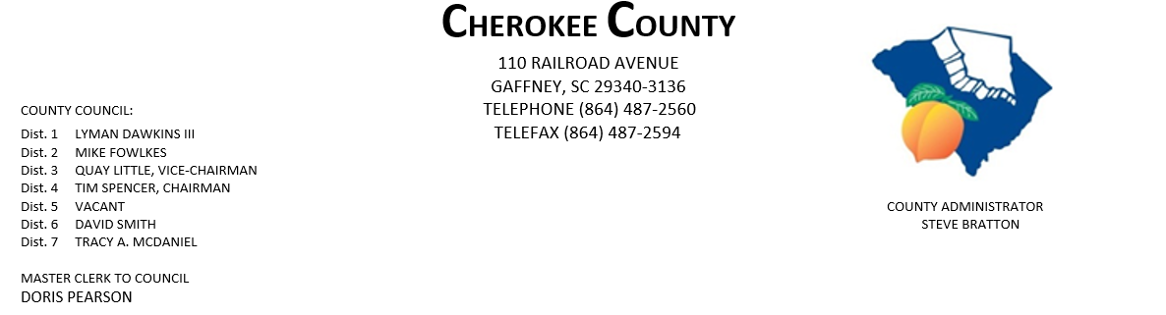
AGENDA FOR THE REGULAR MEETING OF COUNTY COUNCIL
MONDAY, OCTOBER 19, 2020, 5:00 P.M.
CHEROKEE COUNTY ADMINISTRATION BUILDING
COUNTY COUNCIL CHAMBERS, 1st FLOOR
110 RAILROAD AVENUE, GAFFNEY, SC 29340

- CALL TO ORDER: Chairman Tim Spencer

- INVOCATION:

- ROLL CALL:

- ADOPT AGENDA:

- APPROVAL OF MINUTES: Regular Meeting of 10/5/2020.
- APPROVAL OF CLAIMS: for Cherokee County in the amount of $467,731.42.

7. ORDINANCES: 1st Reading of Ordinance No. 2020-18 amending the Cherokee County Code
Chapter 11 Fire Protection, Article 11, Section 11-93 Gaffney Fire District;
Ad valorem tax – annual levy.

8. ATTORNEYS JOE MATHIS & JIM THOMPSON:

9. ACTION ITEMS:
- 2020 A-Tax Worksheet Distribution List

10. ADMINISTRATOR STEVE BRATTON: County Logo

11. APPOINTMENTS:
a. Appalachian Council of Governments – full council

PAGE 2 – AGENDA FOR REGULAR MEETING, MONDAY, 10/19/2020

11. APPOINTMENTS CONTINUED:
b. Cherokee Co. Tax Assessor/Board of Appeals
i. Dist. 1 – Dawkins
ii. Dist. 2 - Fowlkes

c. Cherokee Co. Board of Adjustments & Appeals
i. Dist. 1 – Dawkins
ii. Dist. 2 – Fowlkes
iii. Dist. 3 – Little
iv. Dist. 5
v. Dist. 6 - Smith
vi. At-Large – Council

d. Cherokee Co. Citizen Planning Commission
    - Dist. 1 – Dawkins
    - Dist. 2 - Fowlkes
    - Dist. 5 -
    - Dist. 7 – McDaniel

e. CKC VFD - Dist. 7 – McDaniel

f. Cherokee Co. Recreation District Board – full council.

g. Cherokee Creek Fire District/BOC – one appointment - Dist. 2 – Fowlkes & Dist. 4 - Spencer

h. Goucher-White Plains Fire Dist. – Dist. 5

i. Piedmont Community Actions Board of Directors – full council

j. Upstate Workforce Board – full council

12. EXECUTIVE SESSION: pursuant to Section 30-4-70(a)(2) for the purpose of receiving legal advice
concerning two contractual matters.

13. ACTION TO BE TAKEN FROM EXECUTIVE SESSION:

14. NEW/OLD/OTHER BUSINESS:

15. ADJOURNMENT:

dfp
10/16/2020

