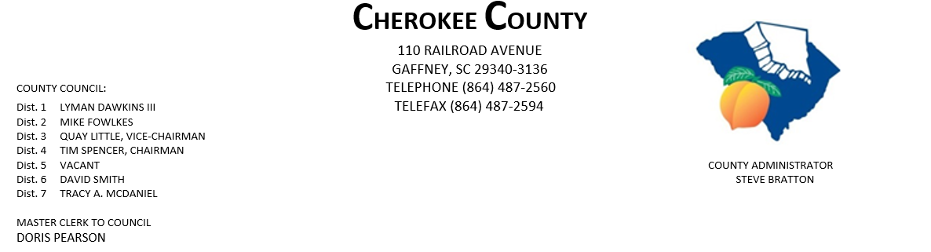
AGENDA FOR THE REGULAR MEETING OF COUNTY COUNCIL
MONDAY, OCTOBER 5, 2020, 5:00 P.M.
CHEROKEE COUNTY ADMINISTRATION BUILDING
COUNTY COUNCIL CHAMBERS, 1st FLOOR
110 RAILROAD AVENUE, GAFFNEY, SC 29340

- CALL TO ORDER: Chairman Tim Spencer

- INVOCATION:

- ROLL CALL:

- ADOPT AGENDA:

- APPROVAL OF MINUTES: Regular Meeting of 9/21/2020.
- APPROVAL OF CLAIMS: for Cherokee County in the amount of $670,256.29.

7. ATTORNEYS JOE MATHIS & JIM THOMPSON:

8. ACTION ITEMS:
- Employee Grievance Committee Appointment

9. ADMINISTRATOR STEVE BRATTON:
- Community Visioning Update
- CTCL COVID Response Grant
- 2019 Delinquent Tax Redemption Period
- Public Works Complex Update

10. APPOINTMENTS:
  - Cherokee Co. Tax Assessor/Board of Appeals
    - Dist. 1 – Dawkins
    - Dist. 2 - Fowlkes
PAGE 2 – AGENDA FOR REGULAR MEETING, 10/5/2020

10. APPOINTMENTS CONTINUED:

b. Cherokee Co. Board of Adjustments & Appeals
i. Dist. 1 – Dawkins
ii. Dist. 2 – Fowlkes
iii. Dist. 3 – Little
iv. Dist. 5
v. Dist. 6 - Smith
vi. At-Large – Council

c. Cherokee Co. Citizen Planning Commission
    - Dist. 1 – Dawkins
    - Dist. 2 - Fowlkes
    - Dist. 5 -
    - Dist. 7 – McDaniel

d. CKC VFD - Dist. 7 – McDaniel

e. Cherokee Co. Recreation District Board – full council.

f. Cherokee Creek Fire District/BOC – one appointment - Dist. 2 – Fowlkes & Dist. 4 - Spencer

g. Goucher-White Plains Fire Dist. – Dist. 5

i. Piedmont Community Actions Board of Directors – full council

j. Upstate Workforce Board – full council

11. EXECUTIVE SESSION: pursuant to Section 40-3-70(a)(2) for the purpose of discussion of matters
Relating to an economic development matter and a contractual matter.

12. ACTION TO BE TAKEN FROM EXECUTIVE SESSION:

13. NEW/OLD/OTHER BUSINESS:

14. ADJOURNMENT:

dfp
10/2/20

